Official Race Charity – Event Weekend Briefing

In advance of race day all charities are required to nominate a designated representative (including a daytime contact phone number) as a point of contact with the event team and to supervise the charity’s activities whilst on site. You must email charity@runninghigh.co.uk with this information by Monday 2nd March.

Contents
Official charity stalls & marquees in the Runners Village 2
General Charity Hall – The Bath Pavilion 3
Branding of Charity Stalls & Marquees 3
Sustainability policy – Change to Race Day site rules 3
Clearing Up Charity Stalls & Marquees 4
Facilities for Charities 4
Parking and Set up 5
Cheering points 8
Competitor details 8
Photographers 8
Event safety rules 9
First Aid and Medical Services 9
Contact details 10

Official charity stalls & marquees in the Runners Village

Marquees and Stalls for the official race charities are located in the Runners Village which is behind:

BATH SPORTS CENTRE, NORTH PARADE ROAD, BATH BA2 4ET

There are four Charity Zones:
Charity Zone 1 Lead Charities – Extra-large marquees (9x12m) in the North East of the Village

Charity Zone 2 Lead Local Charity next to the Information Tent in the centre of the Village

Charity Zone 3 A mix of large (9x6m) and medium (4.5x6m) reserved marquees – around the cricket square in the centre of the Village.
Charity Zone 4 A mix of large (9x6m) and medium (4.5x 6m) reserved marquees – In the South of the Village.
Charity Zone 5 The General Charity hall will be in the Bath Pavilion - in the Bath Sports Centre car park

Each charity will be allocated a designated location by the Charity Director. These locations cannot be changed. For charities with an individual marquee, please see attached ‘Individual reserved charity marquee map’. This map is NOT to scale and NOT to be sent out to your runners as marquees will not be numbered on the day and is only for you to see your location. When instructing your runners, please use the Zone references.

Runners and supporters should be instructed to follow the ‘Red Route’ signage to the Runners Village at Bath Sports Centre (North Parade Road). From the Village the Half Marathon runners follow colour-coded routes to their designated start bays (white, green and orange), whilst spectators and Family Fun Run entrants follow the separate 'Blue Route' signage to the start/finish area.

The Charity Director and assistants will be on hand during the set up period to assist with queries, and to ensure that the designated layout is adhered to.

All charities are requested to sign in with the charity team in the Information tent both on your arrival and before departure from site.

Marquees will be provided with fixed allocations of 1.8m (6ft) trestle table and chairs as indicated

Marquee size | Chairs | Tables
4.5 x 6m | 15 | 3
9 x 6m | 30 | 6
9 x 12m | 40 | 10

General Charity Hall – The Bath Pavilion

For the fourth year; the main charity hall will be situated in the Bath Pavilion, at the main entrance to the venue off the Sports Centre car park on North Parade Road, BA2 4EU. The Pavilion will be signposted with flags or banners reading ‘Race Charities’. A table plan indicating the position of each charity within the hall will be provided at the entrances and is attached with this document.

Each charity will be provided with a standard 1.8m (6ft) trestle table plus 2 chairs.

Branding of Charity Stalls & Marquees

Charities are encouraged to make the most of their allocated space, permitting branding on tables, and freestanding branding against adjacent marquee or hall walls. Do not use adhesive tape or pins to secure branding, or use marker pens on hall or marquee walls.

Charities taking reserved marquees may erect freestanding flags, boards or banners in the designated space immediately outside their marquee. The location and suitability of this additional branding must be agreed with the event charity team before erection. All such signs must be in place before 8.00am on race day. Any signs erected after this time, or without consent will be removed.

Branding inside the hall and marquees, and on runners T-shirts etc may carry logos or advertising from ‘competing brands’ (defined as a brand competing with the event sponsors or partners), but branding outside marquees may not.

All fixings must be removed at the end of the day, and any damage caused to the hall or marquees will be charged back to the respective charity.

Sustainability policy – Change to Race Day site rules

We have always been conscious of the environmental footprint of the Bath Half Marathon, and we work hard with our suppliers, contractors, partners and volunteers to reduce waste, encourage re-use and maximise recycling, constantly challenging ourselves to do more.
In 2019 we announced we were embarking on a new challenge to eliminate single use plastic from our event by 2021, starting with changes to our water stations. For last year’s event we provided water refill points in the Runners Village, and at the on-course water stations, where runners could re-fill their own water bottles. We also provided water in compostable cups at the last of our three water stations, as an alternative to bottled water.
Following positive feedback from competitors in our 2019 post-race survey, and exciting work over the summer with a new water supply partner, Wessex Water and our waste management contractor MJ Church, our intention to accelerate this process and eliminate single use plastic at the 2020 Bath Half from all drink stations (using refill points for runners’ own bottles and compostable cups) and our goody bags. This forms a central part of our emerging sustainability strategy for the event.
We are asking all our charity and commercial partners, and caterers to join us in making the 2020 Bath Half single use plastic free by providing alternatives to plastic bottles, cups, balloons, cheer sticks (or clappers), drinks stirrers, charity donation bags etc. at both the Runners Village (including charity marquees) and cheering stations on the course route. There will of course be a ‘common sense’ approach applied to items like cable ties where there isn’t yet an alternative available.
Charities can use the new Wessex Water ‘Hydro-Zones’ bottle refill points in the Runners Village to fill reusable water bottles to then decant into compostable cups. We will be providing designated bins in the Runners Village for compostable cups to be processed by our new commercial composting contractor.
We appreciate there is an impact to all charities involved and whilst we understand the need to reuse existing stock, we kindly ask that you use this at other events and not at the Bath Half.
Your support is invaluable and will make a huge contribution towards reducing the environmental footprint of the Bath Half.

Clearing Up Charity Stalls & Marquees

Charities are required to maintain their stalls in the village until the event closes at 3.30pm.

Please ensure you remove all your rubbish, branding, decorations etc, returning tables, chairs etc and closing marquees to the position you found them. Charities are asked to use the waste bins provided, segregating their waste to assist our recycling targets and reduce our landfill costs. Any costs incurred by the event team in removing your rubbish, recovering equipment etc will be charged to the respective charity.

Charities are requested not to empty hot water onto the grass, which scorches the grass resulting in us having to pay damages to the Recreation Ground Trust for reinstatement. Please empty hot water into a drain or onto a hard surface, such as tarmac.

Each charity is required to sign out with the charity team in the Information Tent, and to wait whilst their stall or marquee is inspected before leaving site. These conditions will be strictly imposed this year, following mess left in charity marquees in previous years.

Our hire period for the Bath Pavilion ends at 5.00pm on race day, and our contractors will start taking down marquees at 8.00am on Monday morning, so there is no time for us to clear up any other mess after the event.

Facilities for Charities

General Charity Hall – The Bath Pavilion

The Bath Pavilion is a premier event location, with lighting and heating, toilets and café.

Tables and chairs will be in place before your arrival. No power points are available.

Reserved Charity Marquees

The charity marquees will be carpeted, but no heating or power points will be provided – unless otherwise agreed. Tables, chairs etc will be in place before your arrival.

Removable panels will be provided across the front of the reserved charity marquees. These will be removed (if required) by marquee contractors for charities setting up on Saturday. Charities are requested not to remove the marquee panels without first obtaining consent of the Charity Director. We are unable to remove any panels on race day. All panels opened by charities must be closed & marquees secured by the charity before leaving site after the event.

Hot water will be available to charities to provide tea and coffee to supporters. You will be given a wrist band on arrival which will allow you to access to the Volunteer tent (on the tennis court inside the Sports Centre gate – in the SE corner of the site, with reserved toilets adjacent). The urns provided at the volunteer marquee can be used to refill thermos flasks to use in your marquee (please only use the urns marked ‘charity’ as the others are strictly for the event volunteers. Please note that refreshments (tea, coffee etc) and lunches in the Volunteer marquee are for event team volunteers - not for race charities).

There is a mains drinking water supply in the Volunteer tent so you do not need to bring your own.

Charities must provide their own tea, coffee, milk sugar etc. Please assist in keeping this area clean & tidy.

Charities are requested not to empty hot water onto the grass, which scorches the grass resulting in us having to pay damages to the Recreation Ground Trust for reinstatement. If this occurs again this year, we will look pass the cost on to the charity concerned and we will have to consider removing this benefit in future years. Please empty hot water into a drain or onto a hard surface, such as tarmac.

Parking and Set up

No vehicles are allowed to be driven into the Runners Village, or over the vehicle trackway or onto the grass playing pitches.

No parking or off-loading is available at any time in the top Recreation Ground car park (off William Street). All access to site is via Bath Sports & Leisure Centre (North Parade Road, Bath BA2 4ET).

Parking and off-loading is available in the rear Sports Centre car park on Saturday but only by prior arrangement. Towaways will be in force.

All pre-bookable charity parking has sold out again this year.

On arrival to site, and before unloading, each charity’s designated representative is required to register with the charity team in the Runners Village.

Charities stalls need to be set up by 8.00am on the morning of the race before the runners start to arrive. Charities have 3 options for delivering & setting up their stalls:

Saturday 14th March – (Pre-Race Set Up)

Charities wishing to set up or deliver on Saturday should request a parking pass in advance of the event. Please email charity@runninghigh.co.uk no later than Monday 2nd March.

- Access available between 11.00am and 3.00pm. All charities must be off-site before the gates are locked at 4.00pm.
- Drive to the rear of Bath Sports & Leisure Centre off North Parade Road BA2 4ET. A marshal will ask for your name and charity then let you through where when one of our team will meet you with your parking pass. Follow signs and park in the five-a-side courts, accessed from the rear sports centre car park.
- Do not block the access routes, contractors will be working in this area delivering toilets etc and unauthorised vehicles will be towed away. No overnight parking.
- General Charities – the Bath Pavilion. Off-load in the five a side courts and carry materials through the rear doorway into the hall by hand.
- Reserved Charity Marquees – Runners Village. Charities will need to carry materials onto site by hand via the main gate at the rear of the Bath Sports & Leisure Centre.
- Charities must be off-site and car park must be clear by 4.00pm when the Village and Pavilion are closed

Although the site is patrolled by overnight security we cannot accept any responsibility for lost, damaged or stolen items left overnight within the marquees. Valuable items can be left overnight in the Production Office, by prior arrangement.

We regret to inform that due to the theft of our “Dilly” trolleys provided for charities in past years, we are no longer able to offer these for charities’ set up or break down.

Sunday 15th March - (Race Day Set Up)

Charities with pre-booked parking

Your parking pass will be emailed to you before race day and need to be displayed at all times.

Please refer to your pass to see your location.

A – Bath Bowling Club - Pulteney Road, Bath, BA2 4EZ

B - Student Castle parking - Student Castle - 33-34 Pulteney Road, BATH BA2 4EZ

- Access available after 6.00am.
- Drive to your location. Show your parking pass to the steward at the gate, and park in the designated section.
- Off-load in the car park and carry materials by hand approx 0.2 miles (4/5 minute walk), through the rear Sports Centre car park and into the Runners Village across the trackway and grass, or through the rear doors of the Bath Pavilion.
- During the course route road closure period (9.30am – 2.30pm) this car park is inaccessible.
- The car park will close at 5pm.

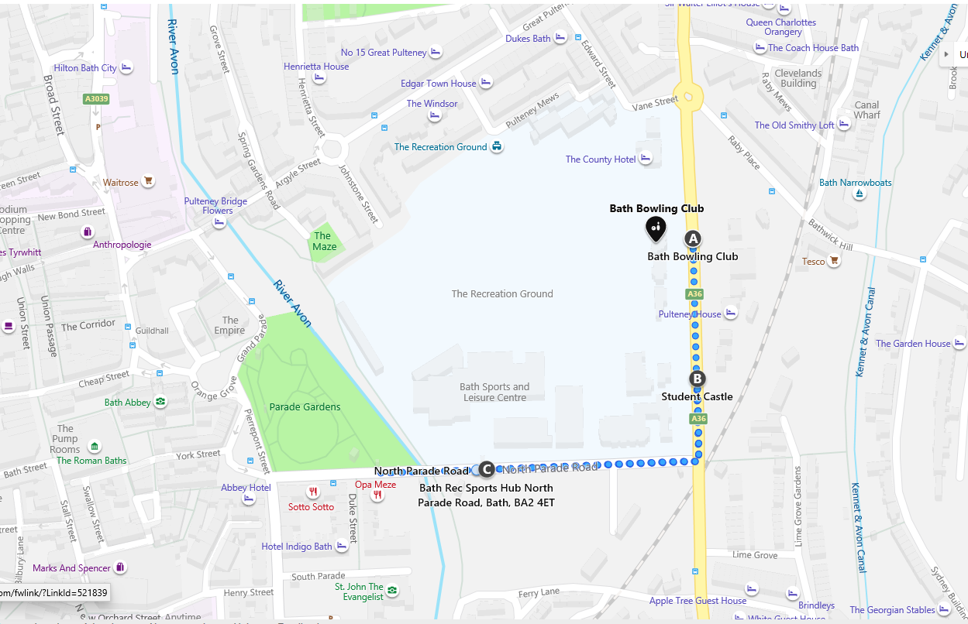

Charities without pre-booked parking

- See http://www.bathnes.gov.uk/services/parking-and-travel/car-parking/parking-bath for nearest public car parks
- For park & ride information – see our race day guide
- There is no vehicle access onto the site for charities– towaways in force. You will need to carry materials onto site by hand via the main gate at the rear of the Sports through the rear Sports Centre car park and into the Runners Village across the trackway and grass, or through the rear doors of the Bath Pavilion.
- We are unable to provide any additional race day parking for charities, other than the pre-booked parking reserved before the event

Please be patient when parking, unloading & setting up, as this is a busy time for all.

Once set up in your stall or marquee, charities are not committed to staying at your stall and of course may wish to watch the start of the race – however we ask that at key times – between 9.00am-11.00am and 1.00pm-3.00pm charity representatives are available at their stall to speak to runners and supporters. The last half marathon runner is expected around 3.30pm. Please note that the only route for charity staff to access the start and finish is via the signposted ‘Blue’ Spectator Routes.

Cheering points

Charities are encouraged to set up their own ‘unofficial’ cheering points on the course route. These can be branded & decorated to suit, but must not interfere or detract from any event branding, official cheering or entertainment points. All branding, rubbish etc must be removed by the charity after the event.

The cheer buses on the course have been pre allocated to our lead charities. Separate details to follow.

We have a number of entertainment points at key locations around the course provided by Battle of the Bands and commercial partners. Charities are asked to keep away from these points.

We are not able to offer reserved cheering spaces on the course this year.

Information for Competitors

Please read the race day guide on our website – this is a good guide to the event day:
https://bathhalf.co.uk/the-event/race-pack-information/

Please note that all timings given are provisional and subject to amendment due to circumstances on the day. Any last minute changes to arrangements will be advised on the race website & notified to runners by email and/or mobile phone text message. Please also look out for announcements on our social media feeds and the public address system.

Race numbers, race chips and race programmes are being posted in batches direct to all charity entrants. Runners whose race pack has not arrived by 2nd March are asked to request a SUBSTITUTE RACE PACK here http://bathhalf.co.uk/substitute-race-pack-request-form/ .

Runners who have moved house without notifying us will need to order and pay for a REPLACEMENT RACE PACK – at a cost of £10 (increasing to £15 on Thursday 5th March). The original race number will be voided. We would encourage runners to make arrangements to collect their race packs where possible. If this isn’t possible and they would like to order a replacement pack, they can do so here: http://bathhalf.co.uk/replacement-race-pack-request-form/

Runners who contact us before 9th March will be posted their Replacement or Substitute race pack by first class mail. After this date they will need to collect their pack from the Information Tent in the Runners Village between 10am-4pm on Saturday 14th March, or from 8am on race day.
Supporters will be able to track the progress of runners using our App, as they pass timing points every 5km round the half marathon route – Keep an eye out for further communications including the link to download the app.
Provisional race results will be published on the race website on the evening of the race. Charities will be able to search for a results list of their registered competitors by entering the charity name (note this may be abbreviated) into the search.

Photographers

Each year we receive a number of requests from charities for accreditation for photographers wanting access to the event.

No passes are required for photography or filming from the public areas at the start/finish, within the Runners Village or on the course route. But we do ask photographers to please avoid more congested areas and to avoid causing obstruction with runners, spectators or event staff and to obey stewards’ or marshals’ instructions if asked to move

We can provide a limited number of start/finish photographer passes, which will allow access to the viewing compound on the pavement beside the start/finish. These are available on a ‘first-come-first-served’ basis and are limited to one pass per charity. Please contact charity@runninghigh.co.uk no later than Monday 2nd March

We regret that access inside the start/finish area and on the stage/podium areas is restricted to event team photographers and broadcast media only. But we are happy to make copies of our own photos available to charity partners free of charge for marketing purposes after the event. Race day photos can be taken from our social media feeds.

Event safety rules

- Each charity is entirely responsible for activities within their own designated area for the duration of the event, including the collection & removal of all rubbish, litter and equipment. Activities must be covered by current public liability insurances and carried out in accordance with any risk assessments provided.

- No cooking stoves, generators, inflammable materials, amplified music, or electrical equipment are allowed on site.

- Exit routes must be kept clear at all times.

- The Bath Half Marathon is a non-smoking event. No smoking is allowed in the Runners Village, in the Bath Pavilion, or in Great Pulteney Street.

- Charity staff must obey safety instructions given by event staff, including conditions of use and instructions attached to any vehicle or staff passes, media and guest access restrictions, instructions on emergency procedures and site evacuation. Charity staff must cease any activity considered hazardous immediately on request by event staff.

- Any charity staff breaching event safety rules or ignoring safety instructions given by event staff will be removed from site.

First Aid and Medical Services

First aid and medical services for competitors (and spectators) are provided by St John Ambulance assisted by paramedics from the NHS South West Ambulance Service Trust and a team of specialist doctors and nurses coordinated by our Medical Director. First aid posts in marked marquees are located at roughly one mile intervals around the course, plus a large first aid tent in the Runners Village and a primary medical facility at the finish in Great Pulteney Street. These are supplemented by mobile response vehicles and ambulances.

Contact details

On race weekend (ONLY), you can contact Kayley Waller, Charity Director, on 07590 538385
We must emphasise that this number is ONLY available across race weekend between the hours of 9am-4pm Saturday and 6am-4pm Sunday, unless it is an emergency.

Please do not give this number to any member of the public.

Kayley Waller (Charity Director) & Rachel Hirst (Charity & Registration Manager)
RUNNING HIGH EVENTS Ltd

Email : charity@runninghigh.co.uk
Tel : 01225 422255

